Prediction of Heart Failure using Machine Learning Classification Algorithm

Steps: As per Day 5 instruction, the following steps are completed.

1. Open already created Waston Studio service
2. Create a Project
3. Add Auto AI Experiment
4. Create a ML instance(Already created instance deleted because of lite plan one instance is applicalble)
5. Associate Machine Learning instance to project
6. Load the data set in Cloud Object Storage(I used UCI repository dataset)

Download link: <https://archive.ics.uci.edu/ml/datasets/Heart+failure+clinical+records>

1. Select the prediction parameter in the dataset- DEATH_EVENT
2. Train the model

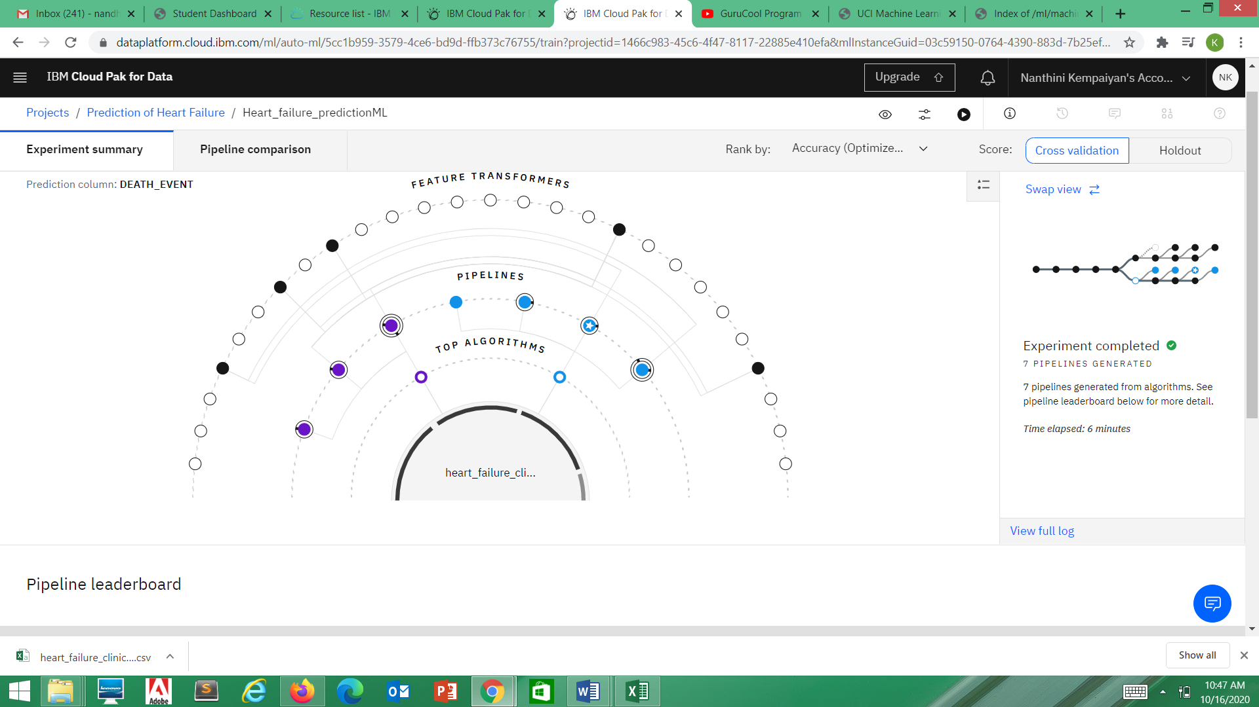

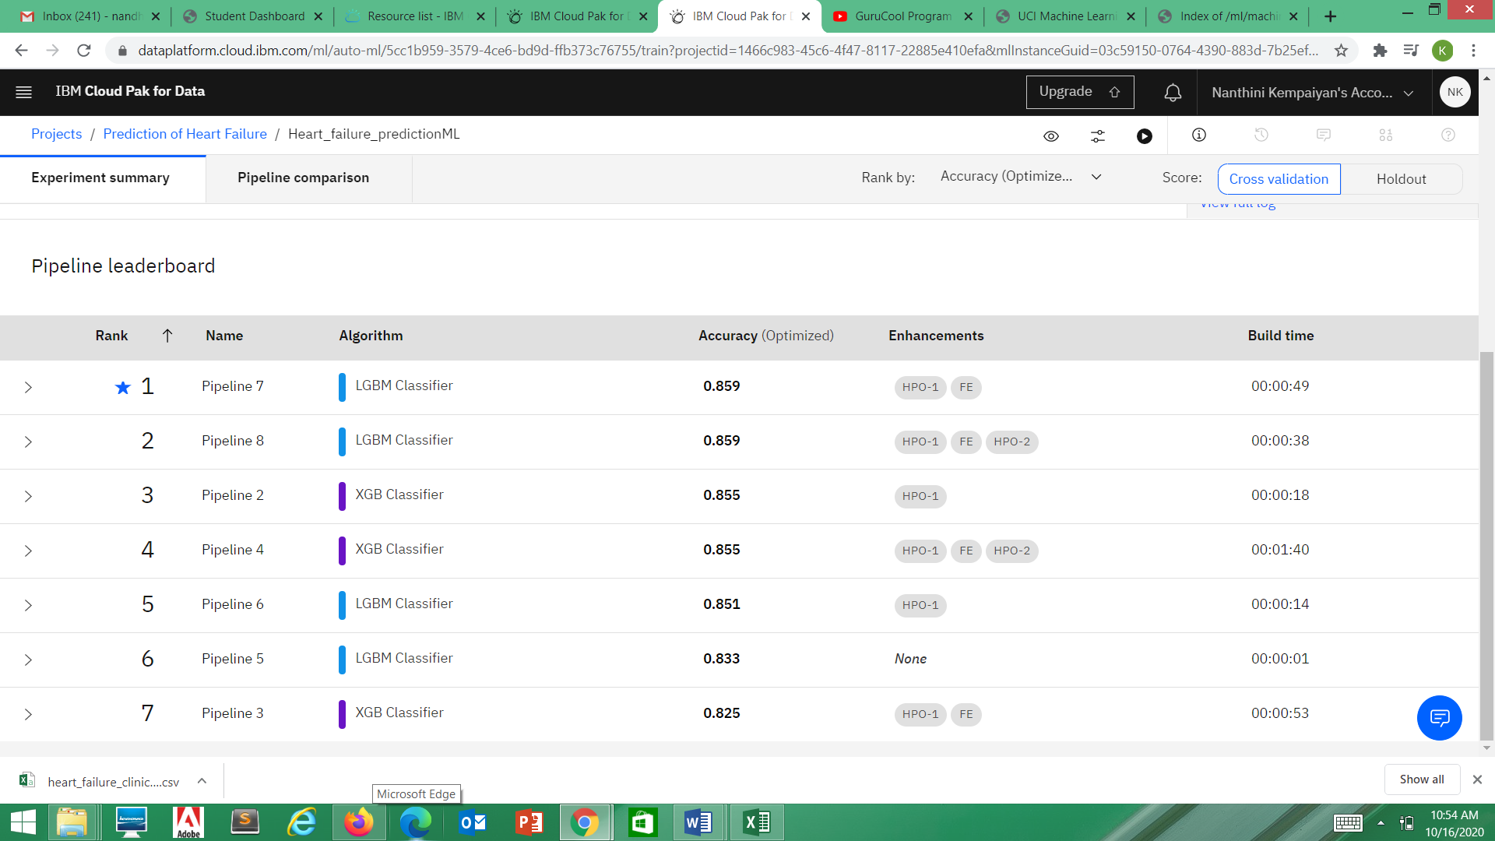

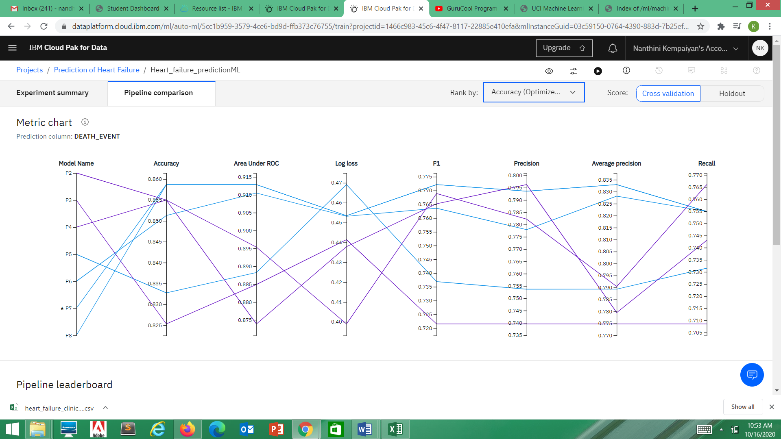

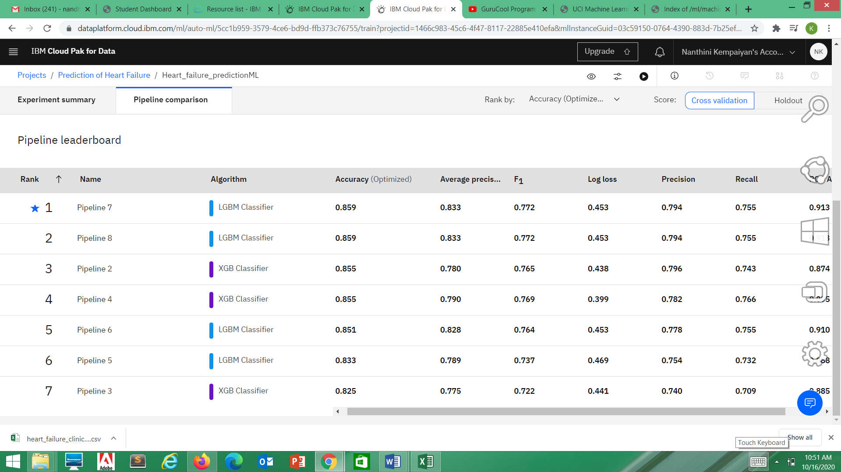

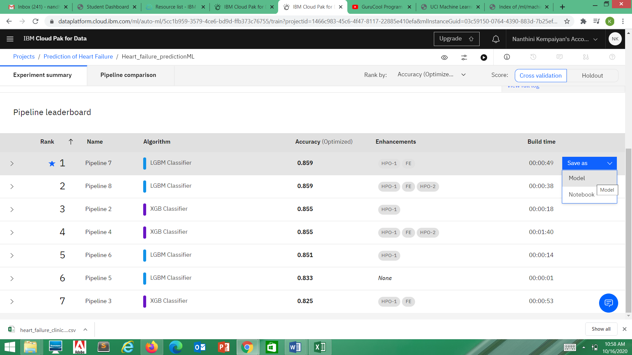

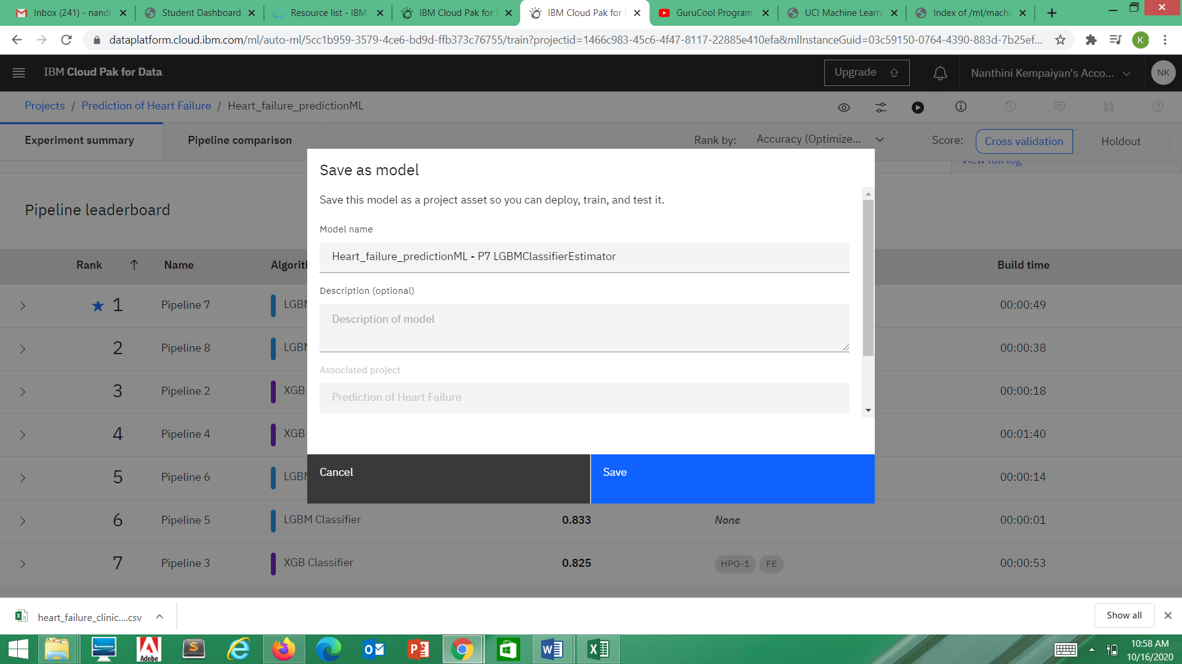

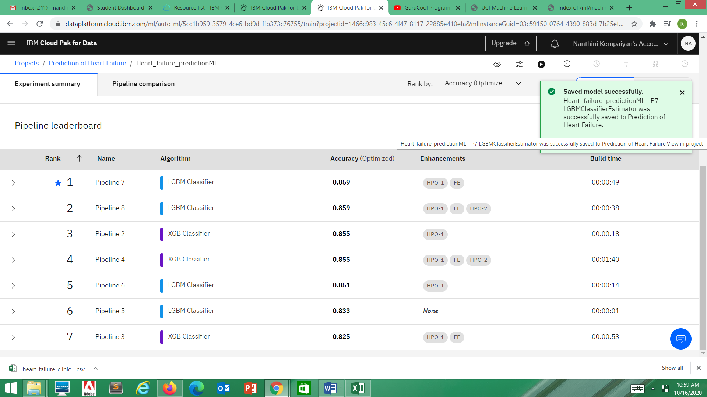

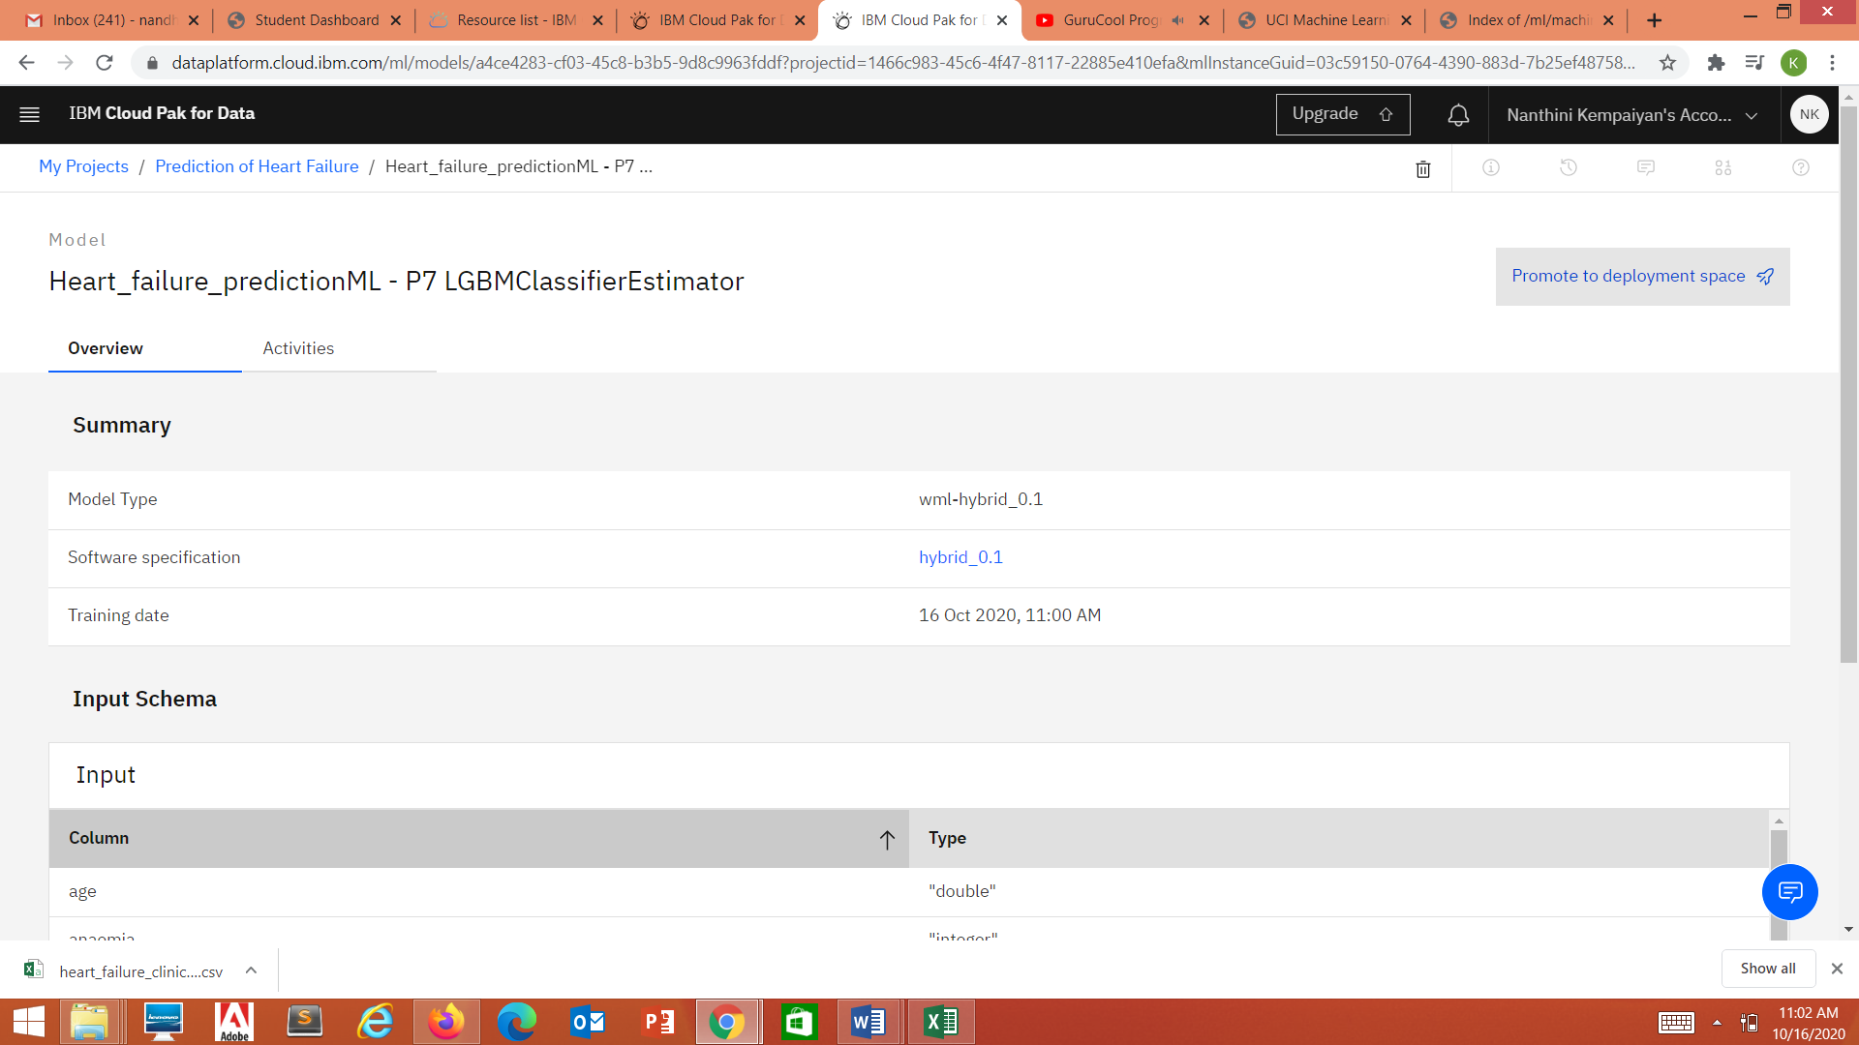

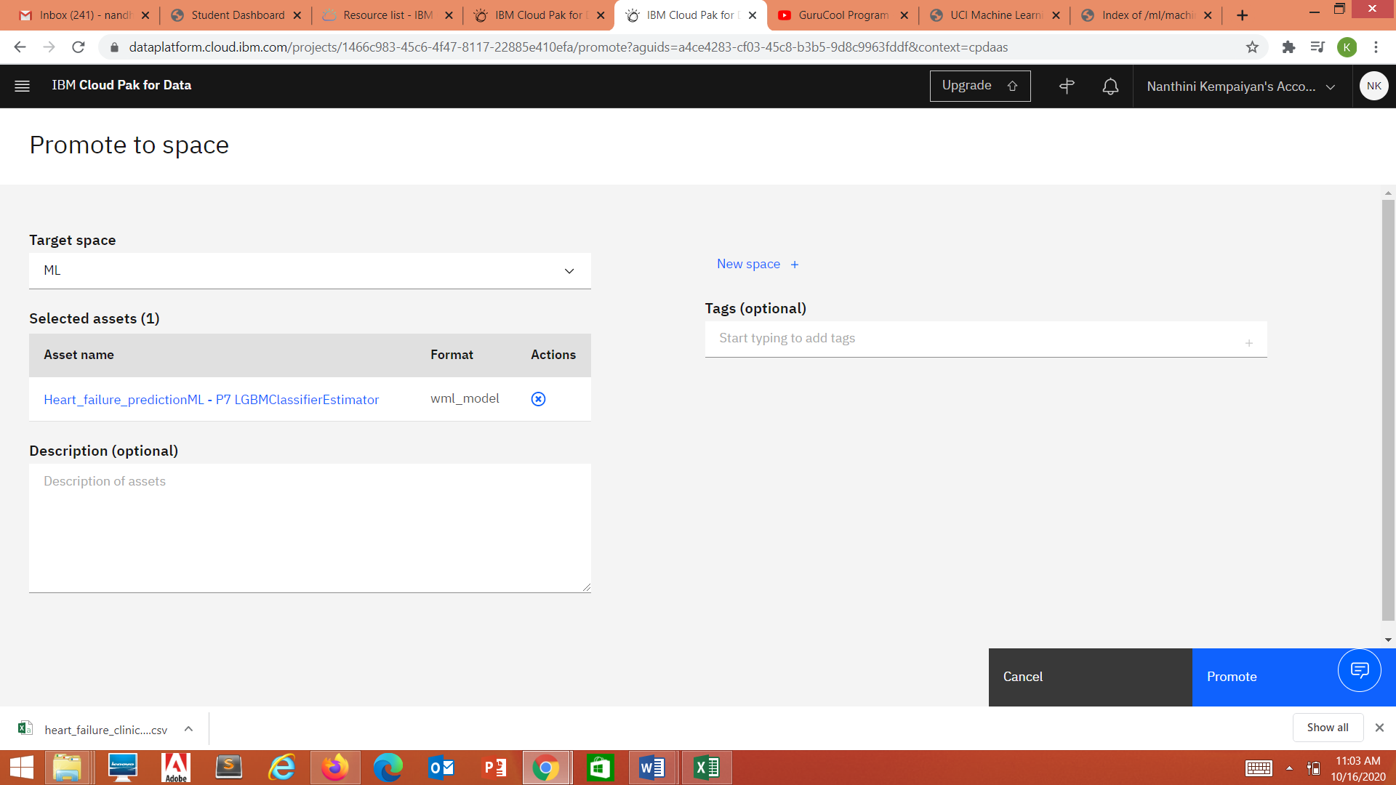

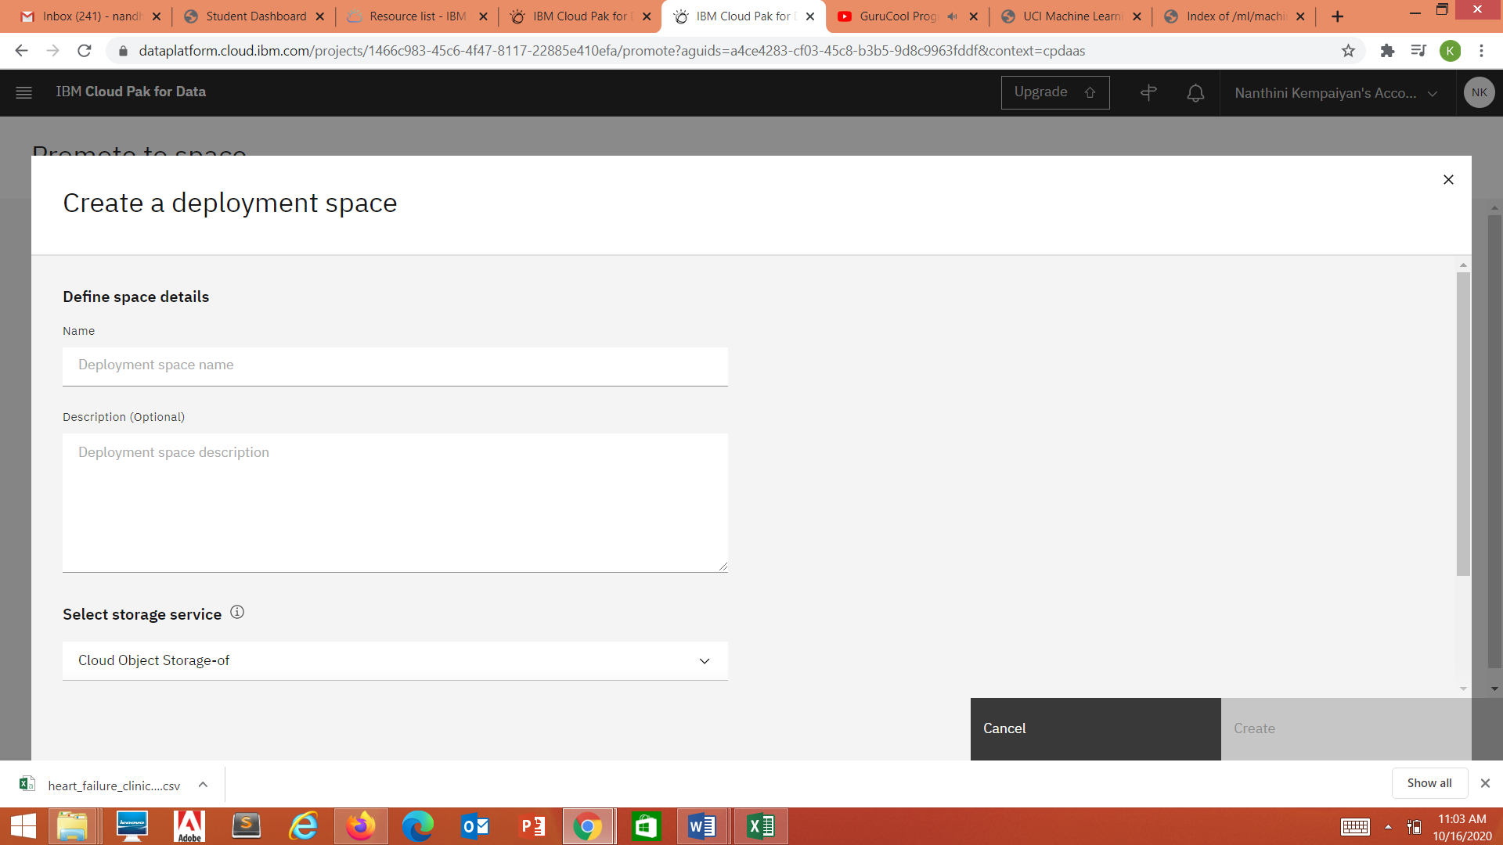

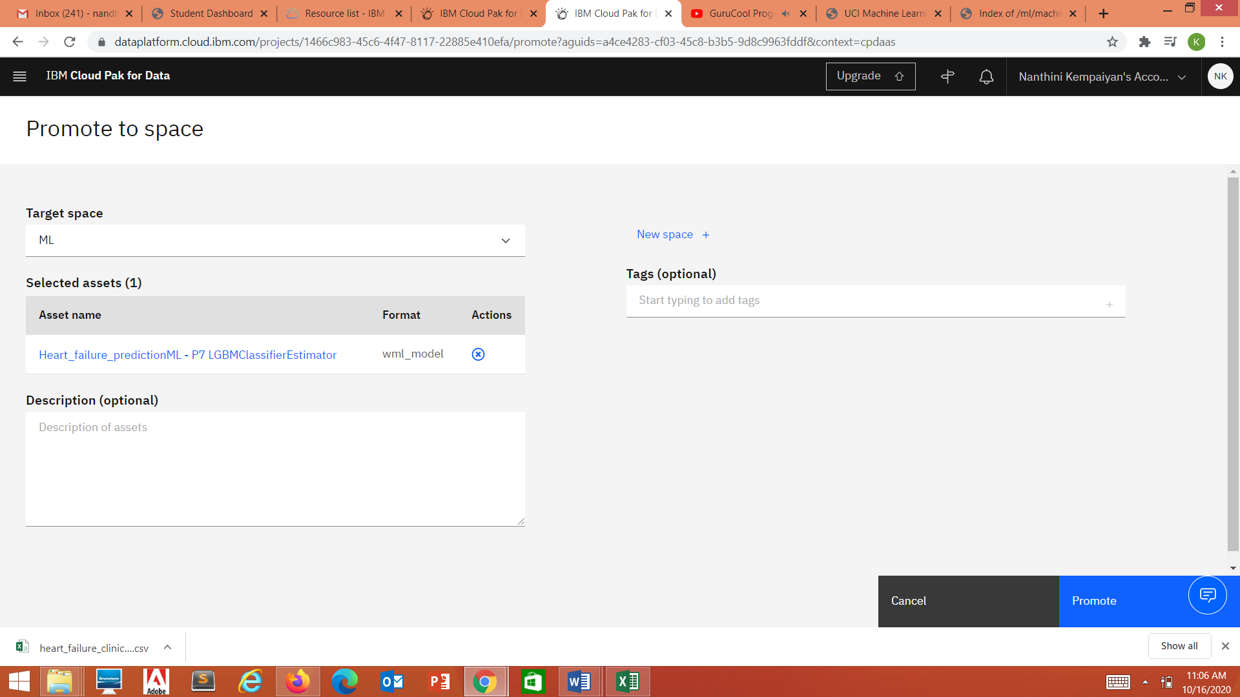

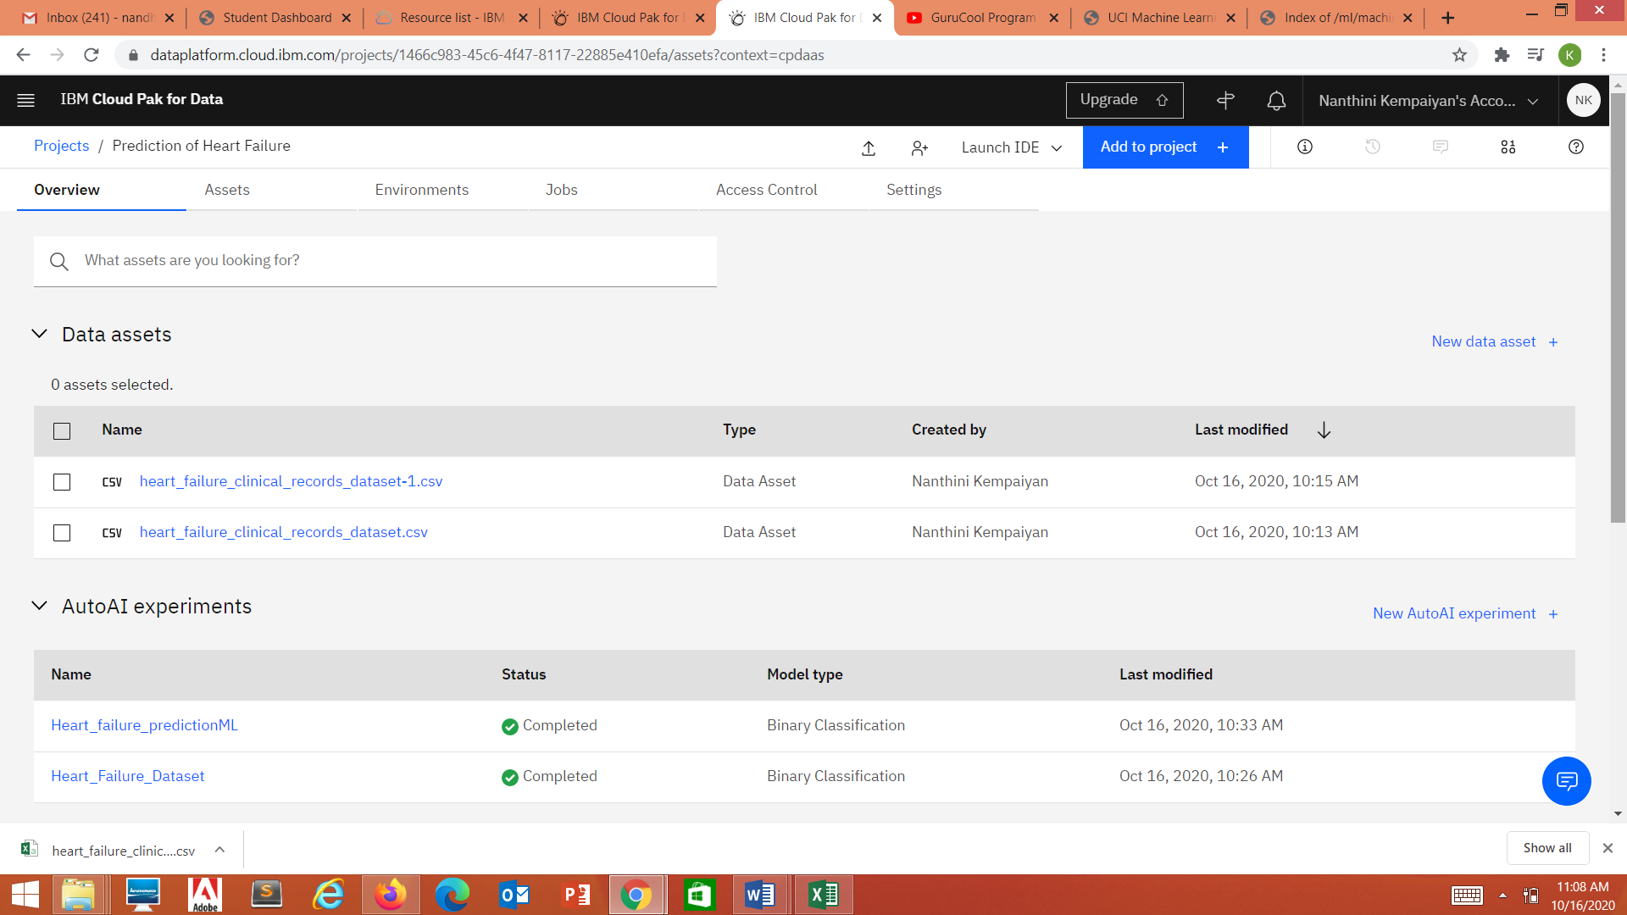

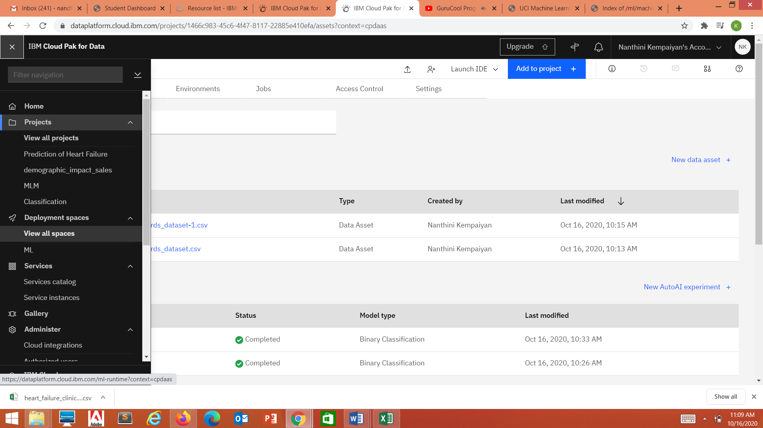

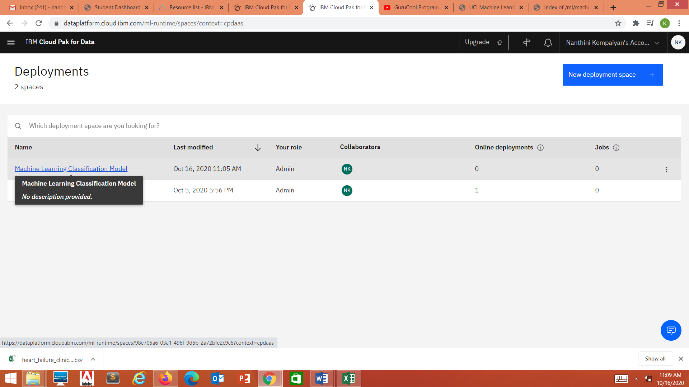

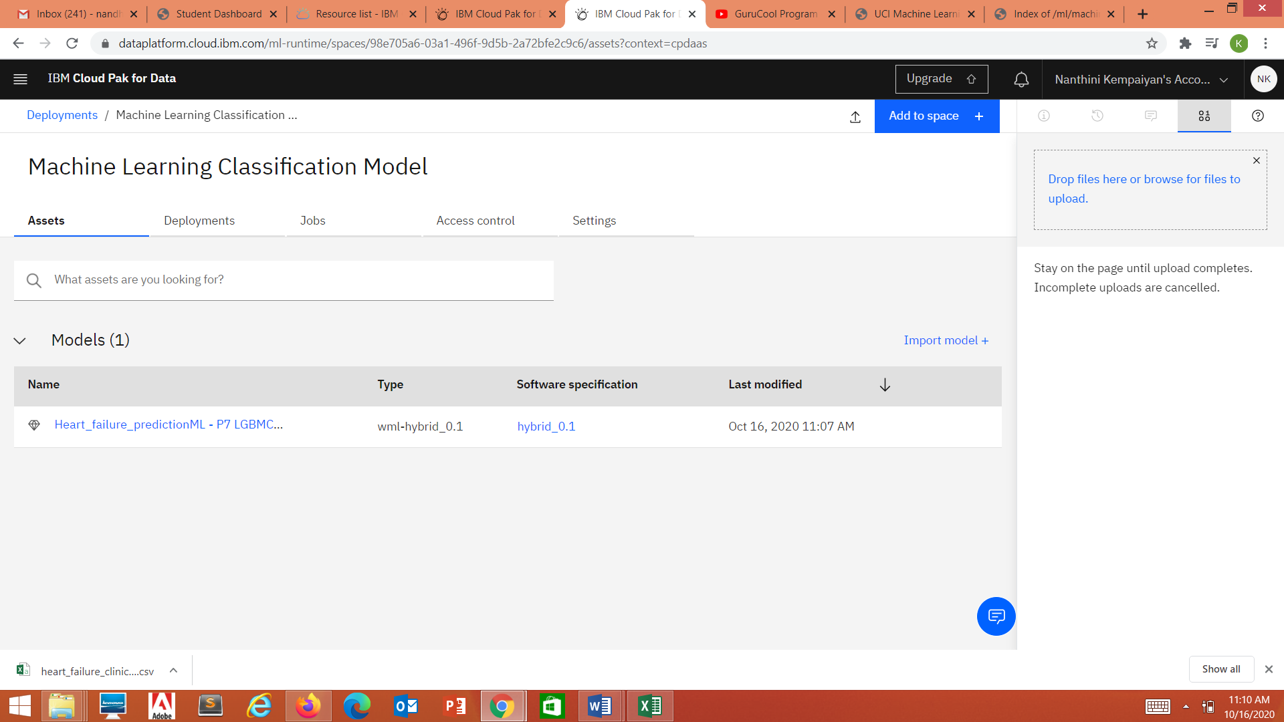

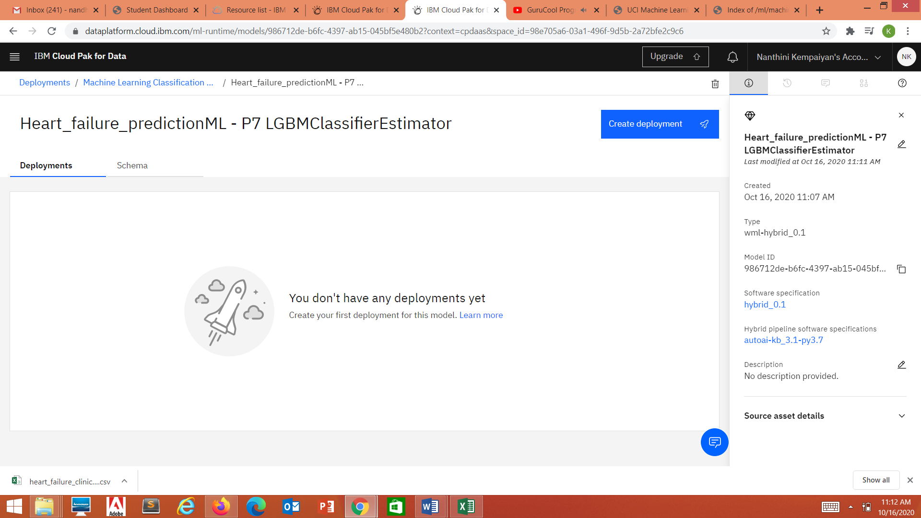

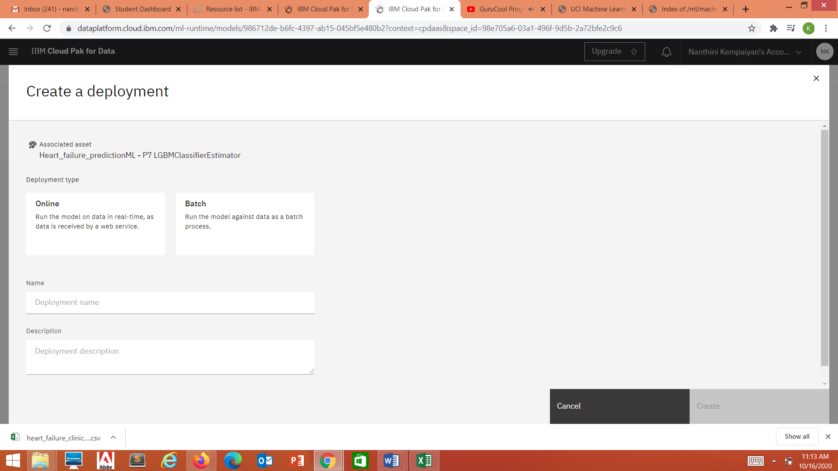

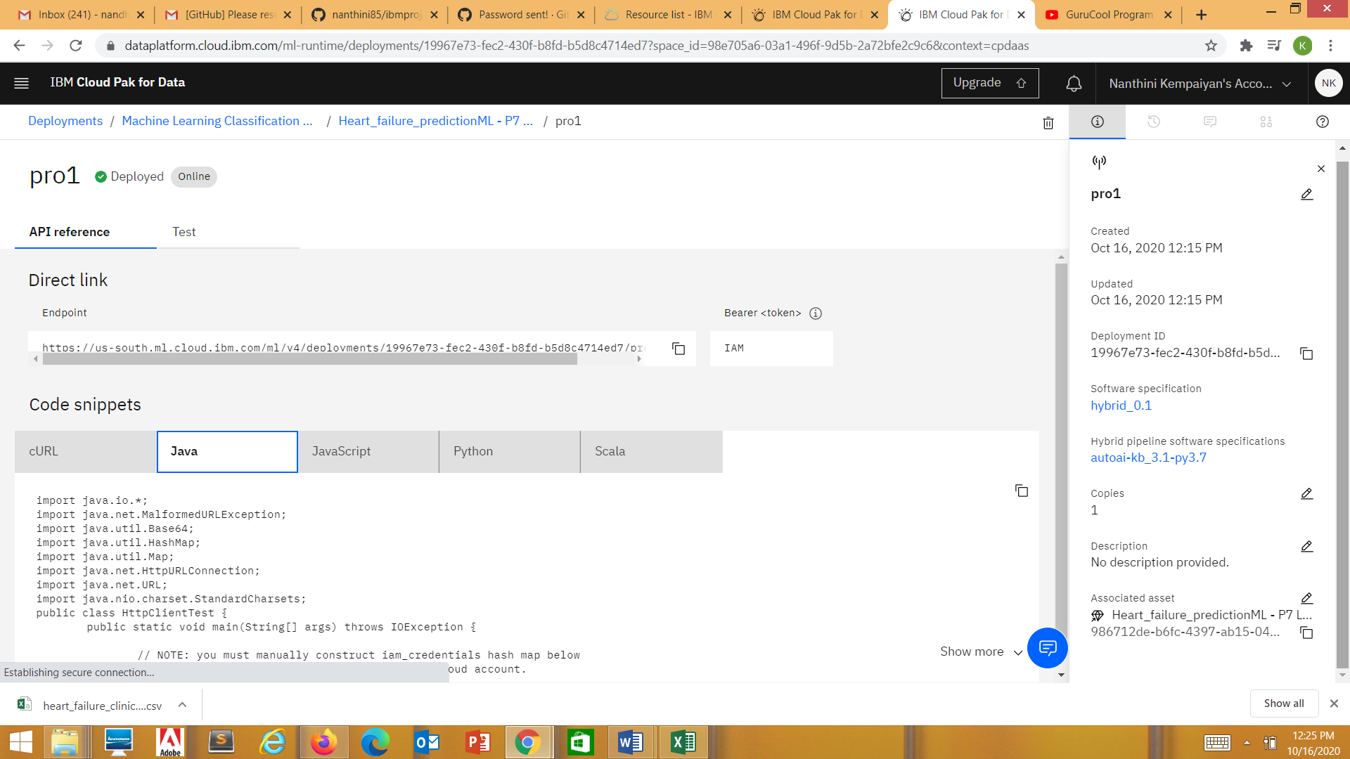

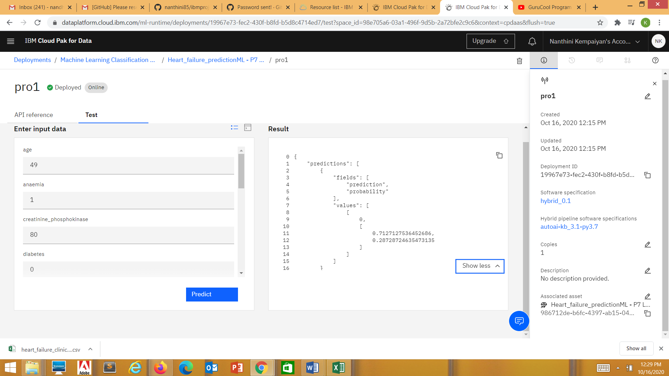

API reference: <https://us-south.ml.cloud.ibm.com/ml/v4/deployments/19967e73-fec2-430f-b8fd-b5d8c4714ed7/predictions>

Test with any sample for the prediction value is correct or not.

Create a resource for nodeRED

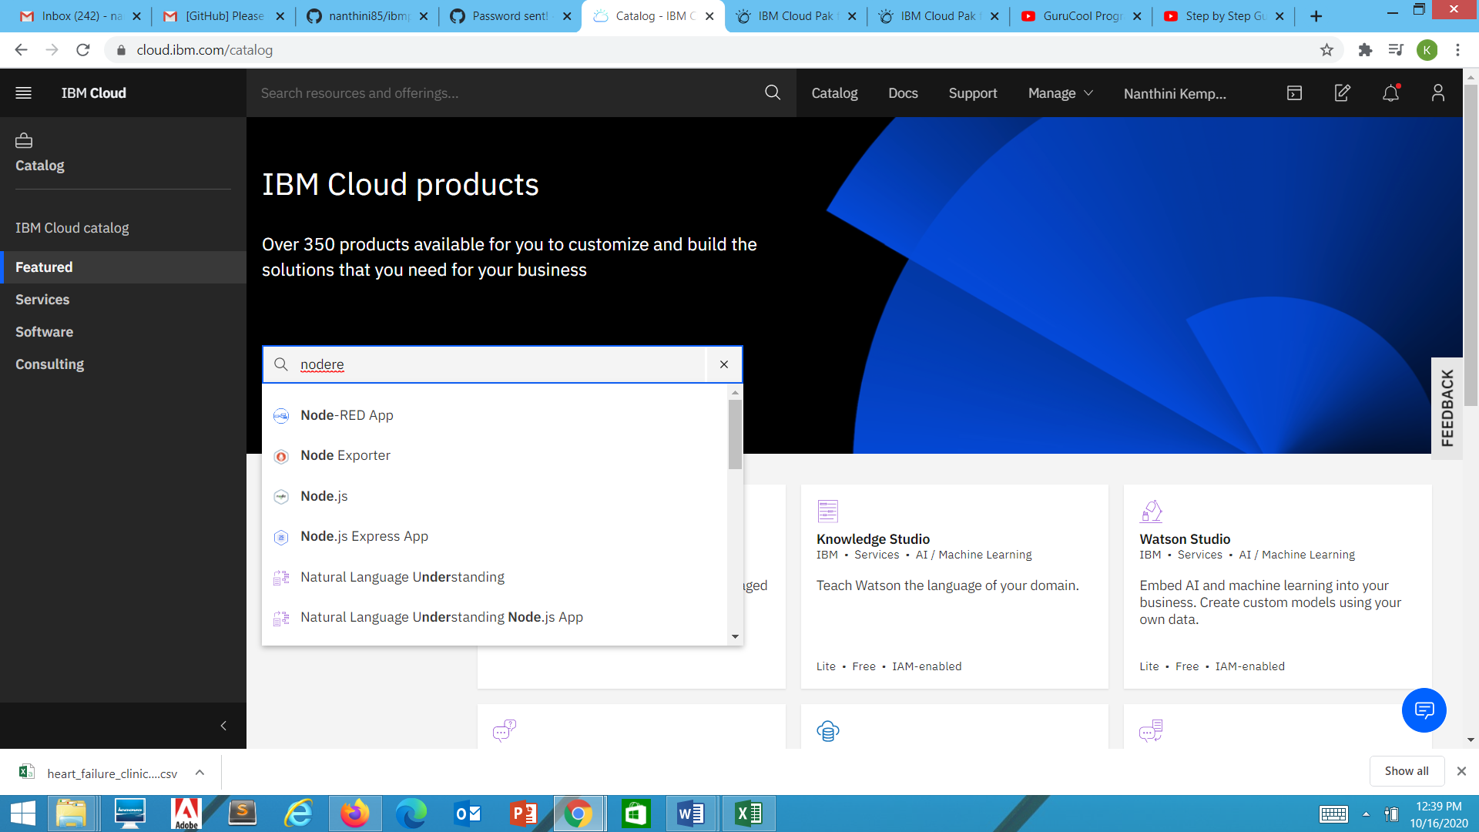

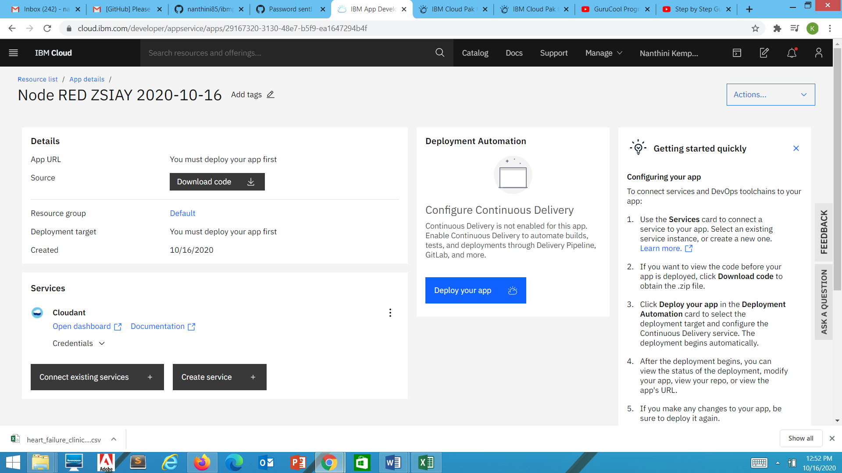 API Key for **N**odeREDBNWKL2020-10-16

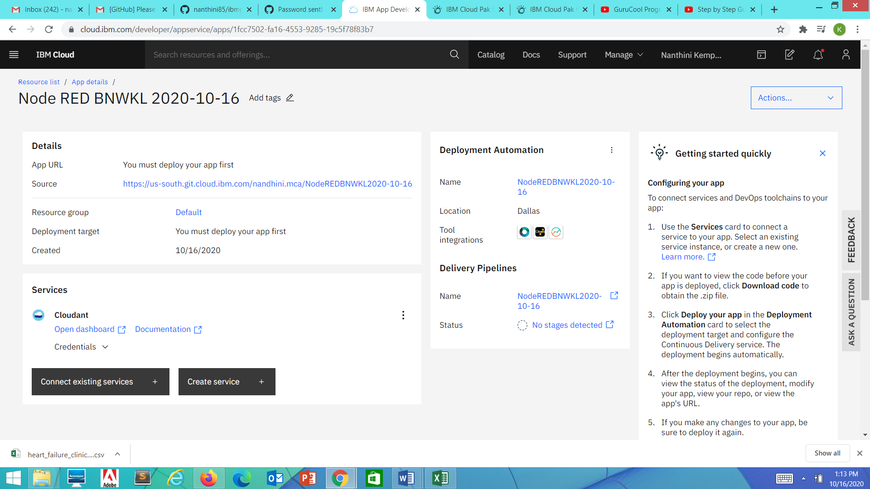

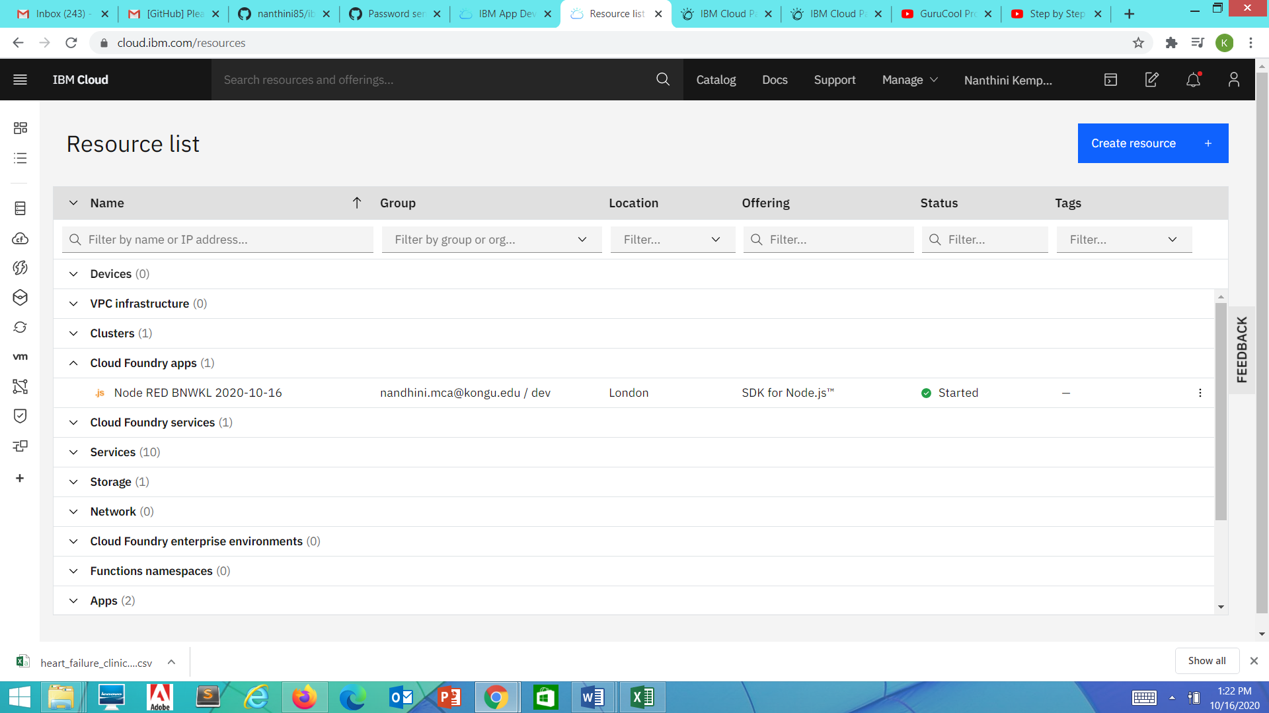

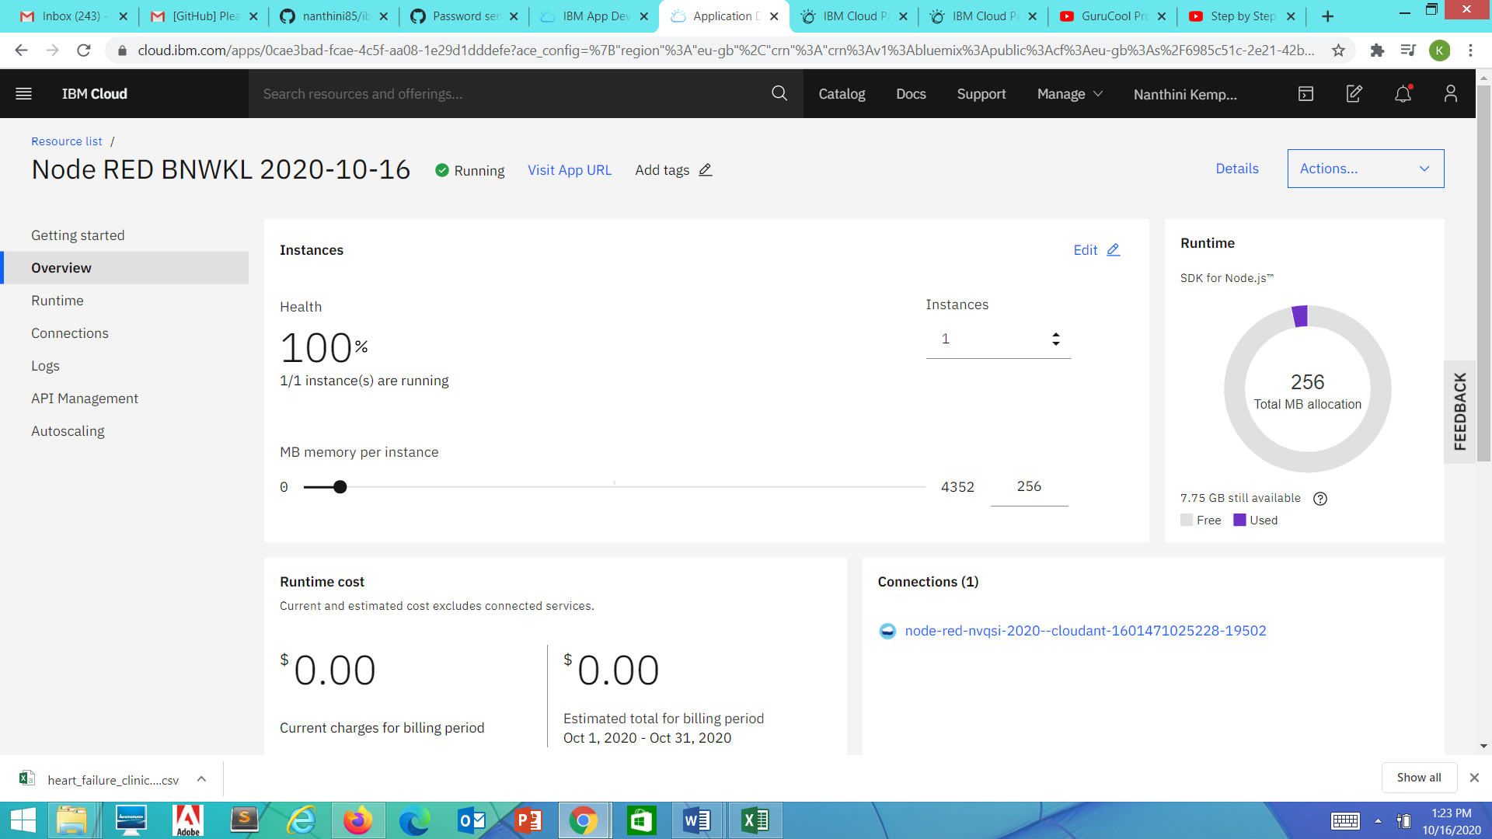

nodeRED App URL: <https://heartfailureprediction.eu-gb.mybluemix.net/>

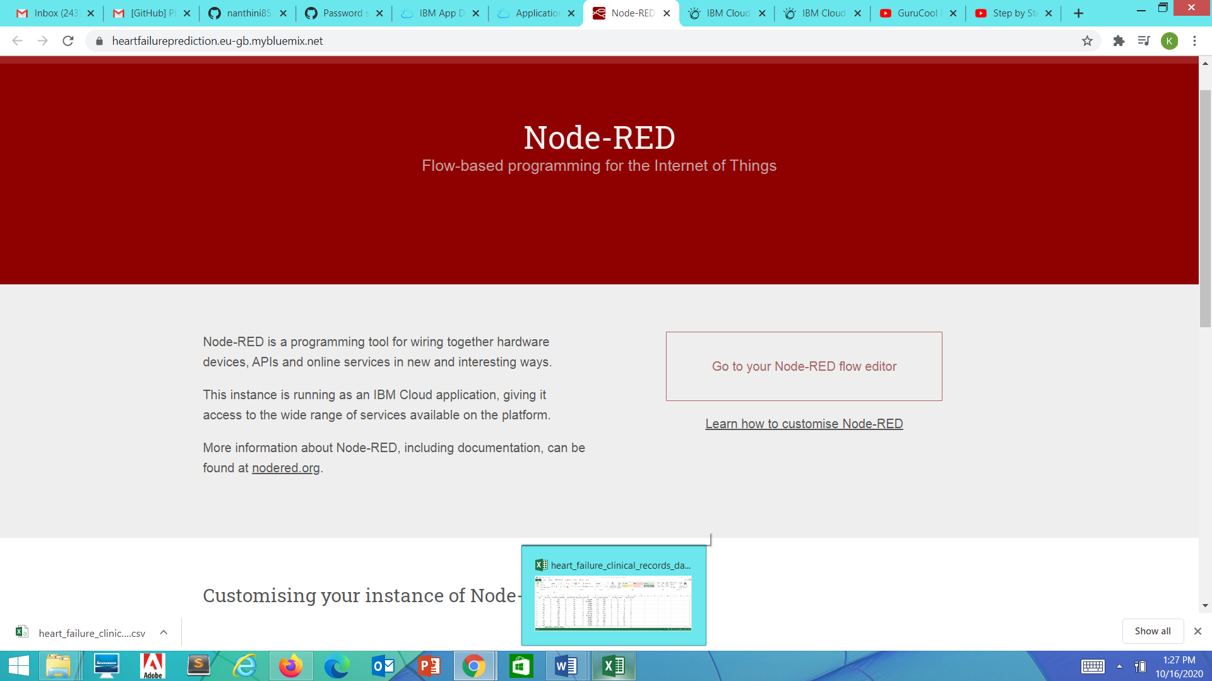

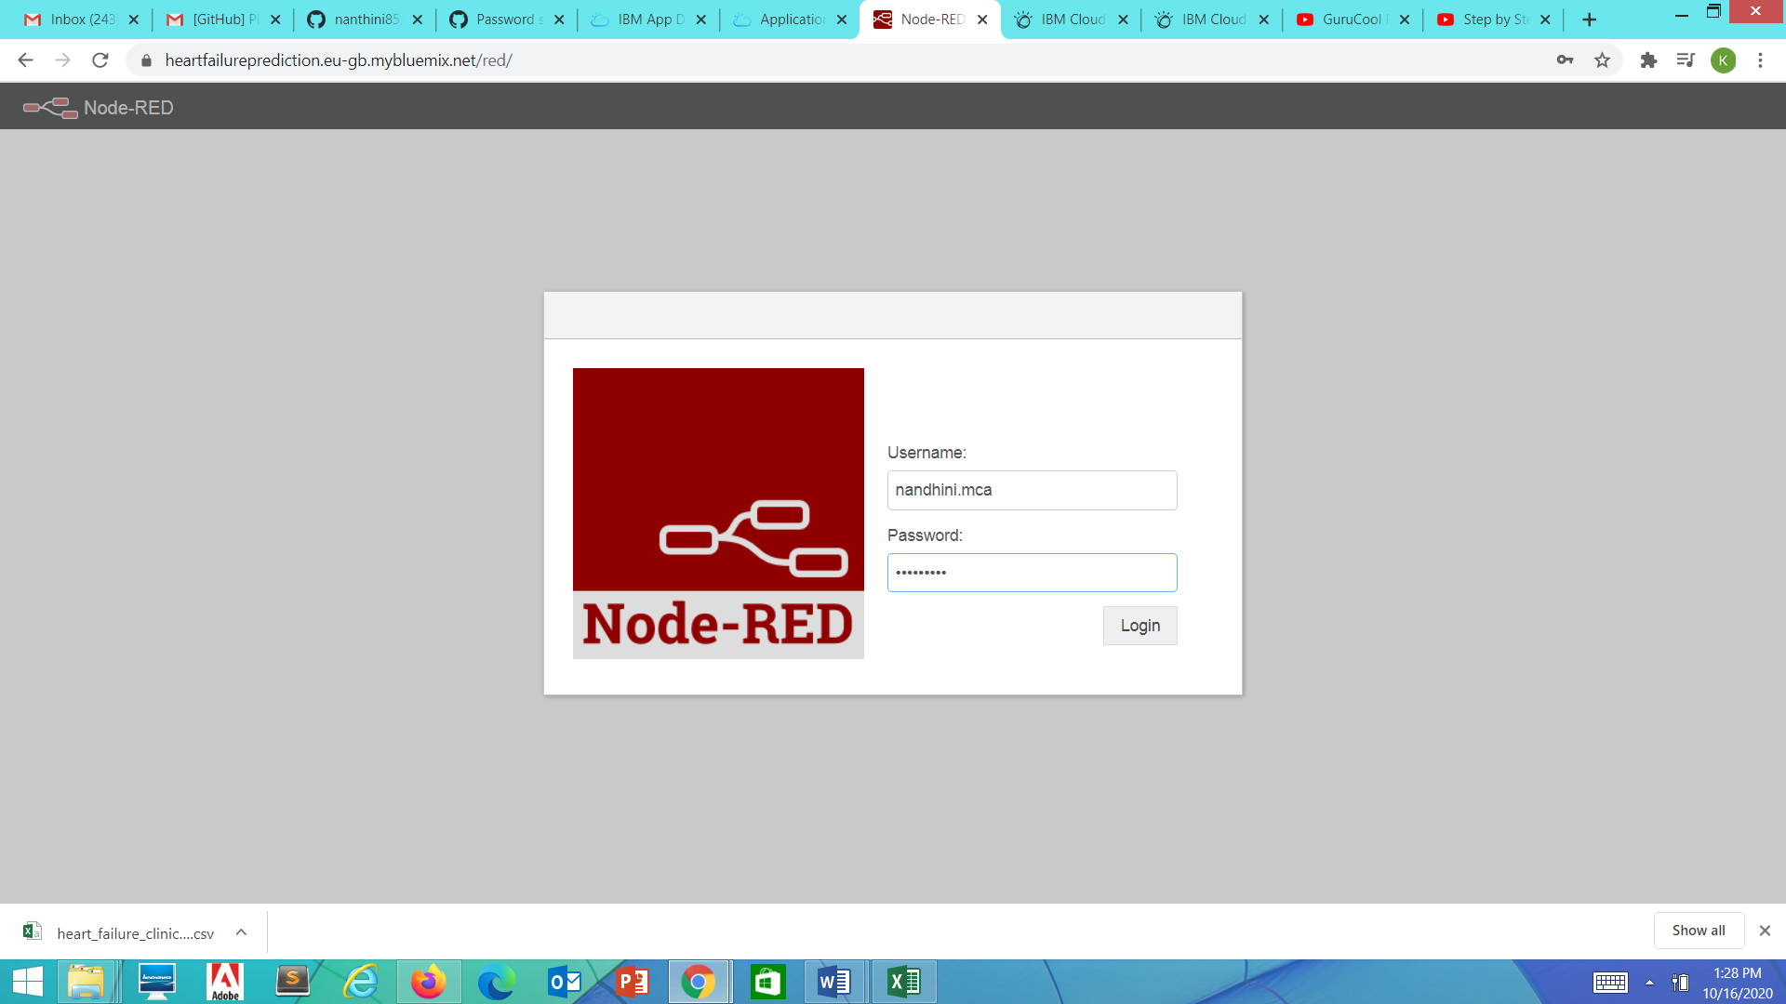

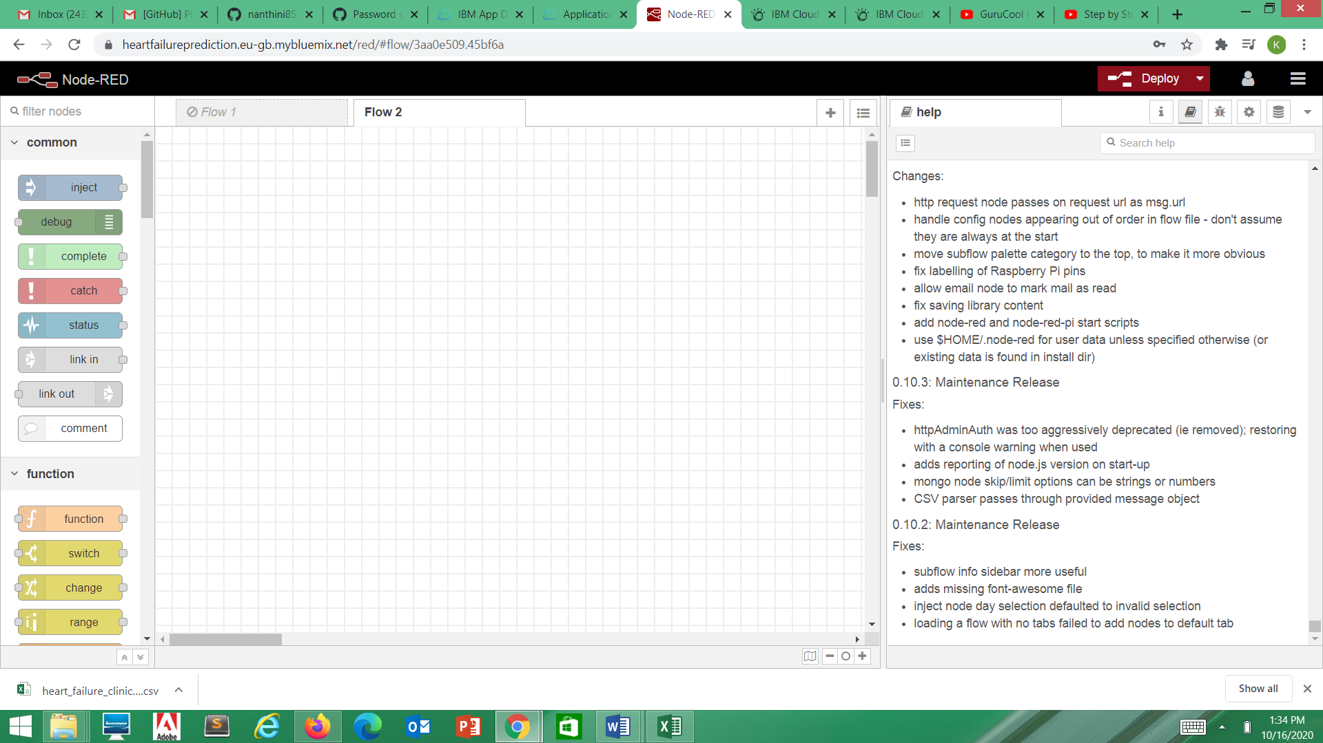

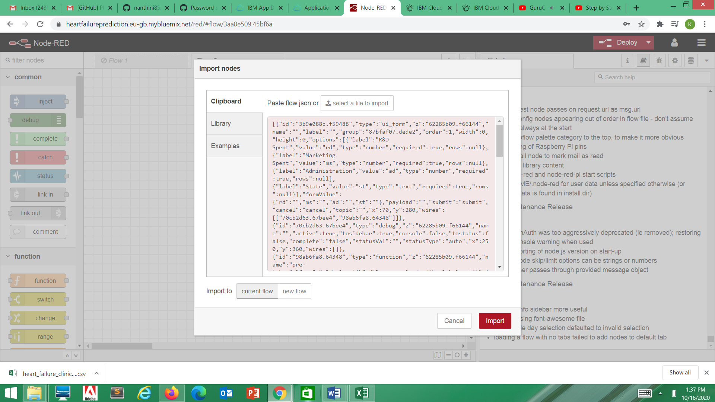

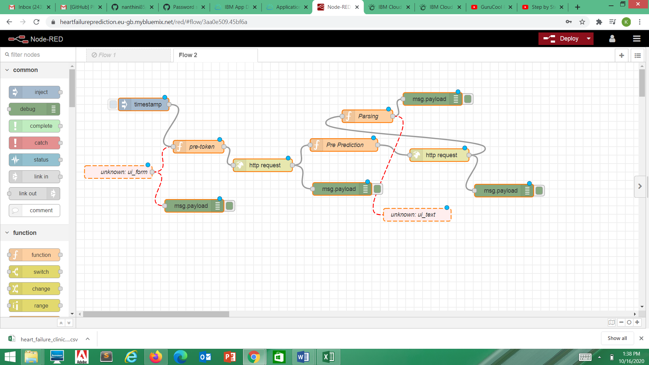

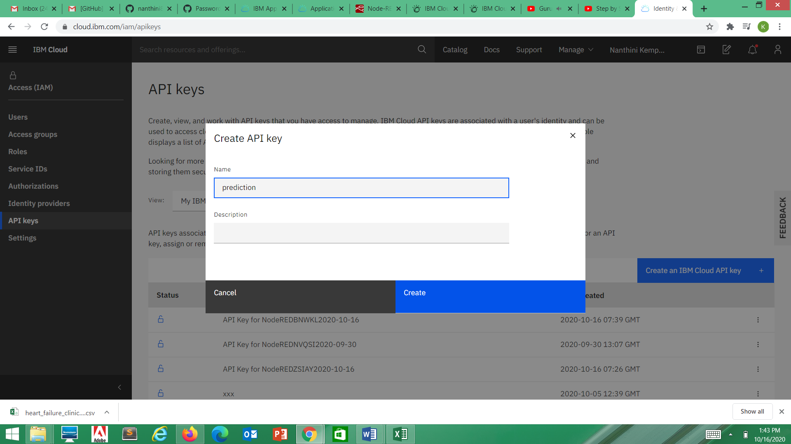

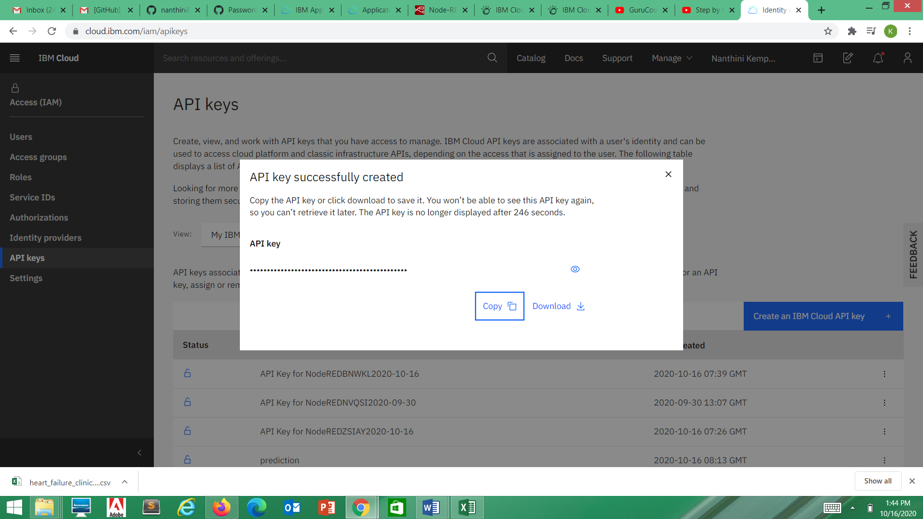

API KEY:OryS5WwDc9sHbRTzr-TcXME-4t9C3G_6UIt29IJFhTim

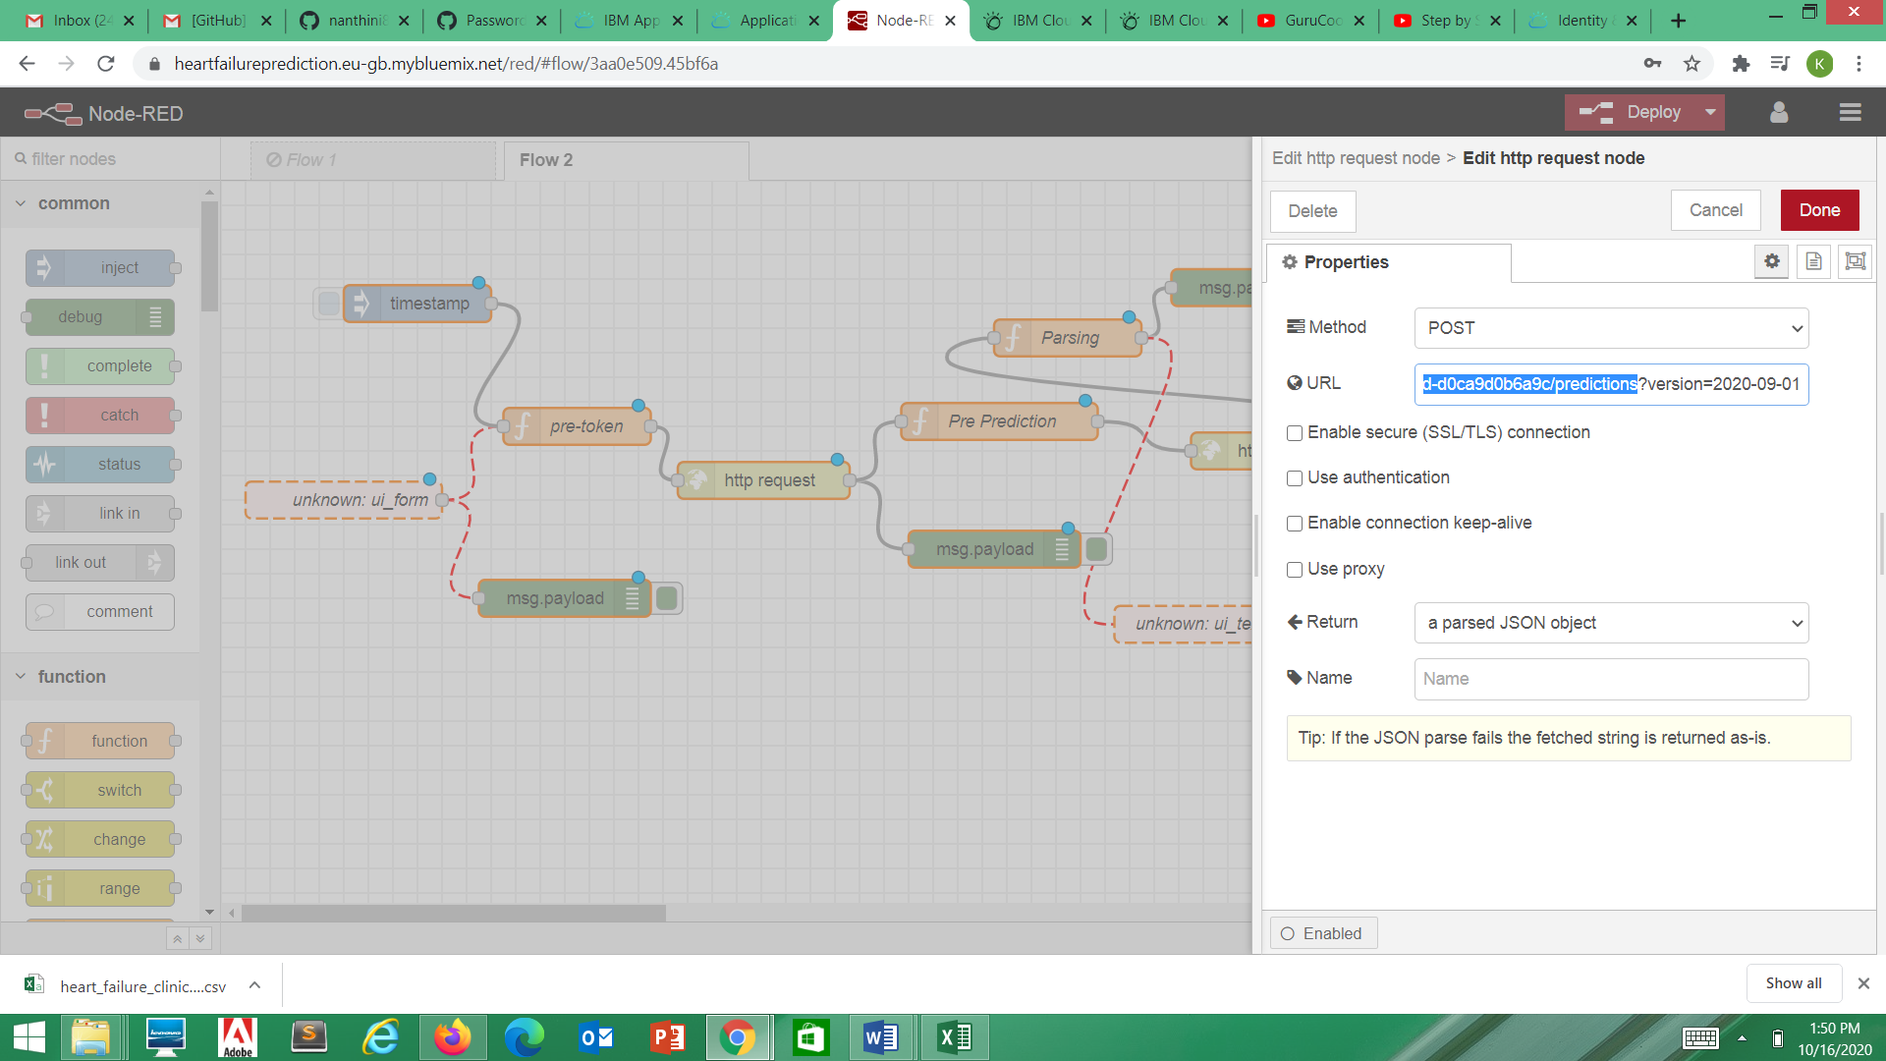

Move on to Deployment tab in ibm cloud

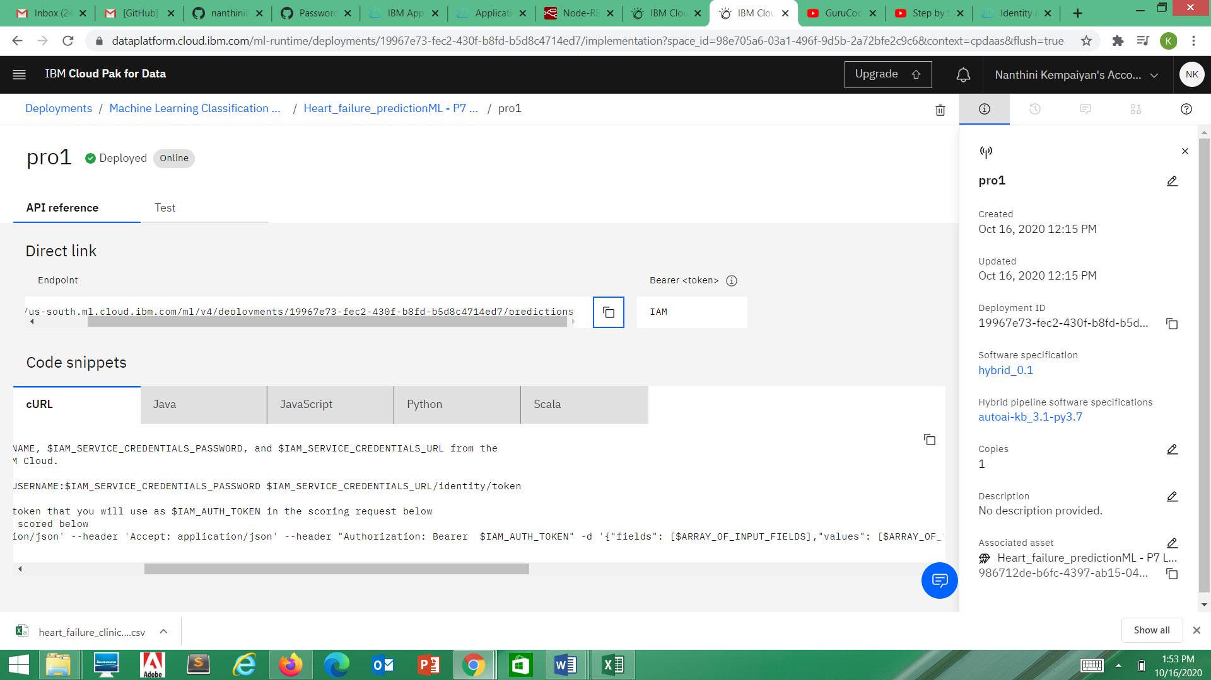

End point:https://us-south.ml.cloud.ibm.com/ml/v4/deployments/19967e73-fec2-430f-b8fd-b5d8c4714ed7/predictions

